**PYTHON PROGRAM 1:  
 Python Program to find the average of all Items in a Dictionary Step1: Get the name as key and marks as value for n students Step2: find the average of the marks of all the students and print it.**

d = dict()

n = int(input("Enter The Number Of Students: "))

for i in range(n):

name = input("Enter The Name Of Student: ")

d[name] = int(input("Enter The Marks Of Student: "))

s = 0

for i in d.values():

s = s + i

print("The Average Of The Marks Of All Students: ", s//n)

**OUTPUT:**

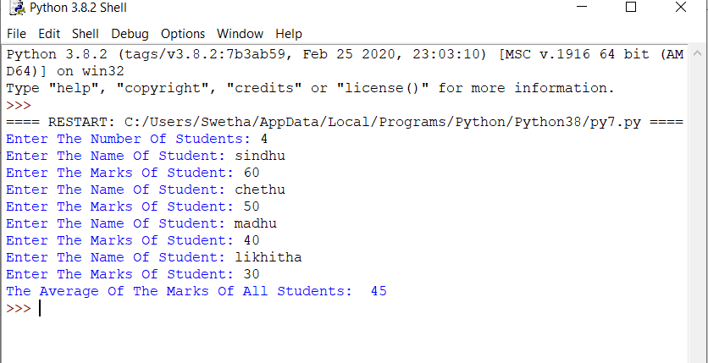

**JAVA PROGRAM 2:**

**Write a Java program to find the nodes which are at the maximum distance in a Binary Tree.**

import java.util.ArrayList;

public class MaxDistance {

public static class Node{

int data;

Node left;

Node right;

public Node(int data){

this.data = data;

this.left = null;

this.right = null;

}

}

public Node root;

int[] treeArray;

int index = 0;

public MaxDistance(){

root = null;

}

public int calculateSize(Node node)

{

int size = 0;

if (node == null)

return 0;

else {

size = calculateSize (node.left) + calculateSize (node.right) + 1;

return size;

}

}

public void convertBTtoArray(Node node) {

if(root == null){

System.out.println("Tree is empty");

return;

}

else {

if(node.left != null)

convertBTtoArray(node.left);

treeArray[index] = node.data;

index++;

if(node.right != null)

convertBTtoArray(node.right);

}

}

public int getDistance(Node temp, int n1) {

if (temp != null) {

int x = 0;

if ((temp.data == n1) || (x = getDistance(temp.left, n1)) > 0

|| (x = getDistance(temp.right, n1)) > 0) {

return x + 1;

}

return 0;

}

return 0;

}

public Node lowestCommonAncestor(Node temp, int node1, int node2) {

if (temp != null) {

if (temp.data == node1 || temp.data == node2) {

return temp;

}

Node left = lowestCommonAncestor(temp.left, node1, node2);

Node right = lowestCommonAncestor(temp.right, node1, node2);

if (left != null && right != null) {

return temp;

}

if (left != null) {

return left;

}

if (right != null) {

return right;

}

}

return null;

}

public int findDistance(int node1, int node2) {

int d1 = getDistance(root, node1) - 1;

int d2 = getDistance(root, node2) - 1;

Node ancestor = lowestCommonAncestor(root, node1, node2);

int d3 = getDistance(root, ancestor.data) - 1;

return (d1 + d2) - 2 * d3;

}

public void nodesAtMaxDistance(Node node) {

int maxDistance = 0, distance = 0;

ArrayList<Integer> arr = new ArrayList<>();

int treeSize = calculateSize(node);

treeArray = new int[treeSize];

convertBTtoArray(node);

for(int i = 0; i < treeArray.length; i++) {

for(int j = i; j < treeArray.length; j++) {

distance = findDistance(treeArray[i], treeArray[j]);

if(distance > maxDistance) {

maxDistance = distance;

arr.clear();

arr.add(treeArray[i]);

arr.add(treeArray[j]);

}

else if(distance == maxDistance) {

arr.add(treeArray[i]);

arr.add(treeArray[j]);

}

}

}

for(int i = 0; i < arr.size(); i = i + 2) {

System.out.println("( " + arr.get(i) + "," + arr.get(i+1) + " )");

}

}

public static void main(String[] args) {

MaxDistance bt = new MaxDistance();

bt.root = new Node(12);

bt.root.left = new Node(13);

bt.root.right = new Node(3);

bt.root.left.left = new Node(9);

bt.root.left.right = new Node(2);

bt.root.right.left = new Node(3);

bt.root.right.right = new Node(5);

bt.root.right.right.right = new Node(6);

bt.root.right.right.right.left = new Node(8);

bt.nodesAtMaxDistance(bt.root);

}

}

**OUTPUT:**

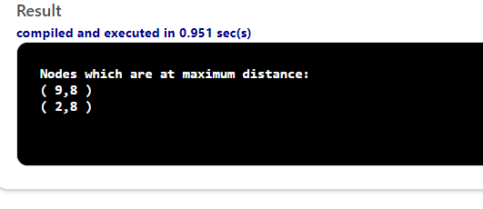

**PYTHON PROGRAM 3:**

**Write a python function that converts a string to all uppercase, provided it contains at least 2 uppercase characters in the first 4 characters. Else print the string as it is**

def to_uppercase(str1):

num_upper = 0

for letter in str1[:4]:

if letter.upper() == letter:

num_upper += 1

if num_upper >= 2:

return str1.upper()

return str1

print(to_uppercase('Java'))

print(to_uppercase('JAva'))

**OUTPUT:**

